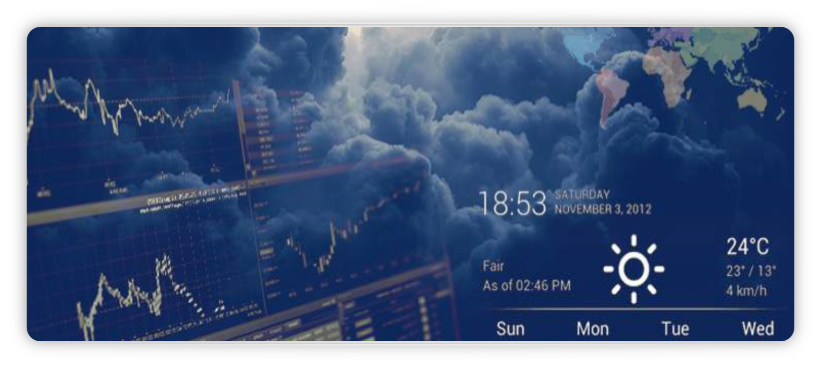

Climate Reader

TEAM MEMBERS

* **ROHITH RAO – LEAD**
* SRILEKHA
* LASYA
* TEJA
* SAMPATH
* RAJINI

*TABLE OF CONTENT*

1. INTRODUCTION
2. SCOPE
3. PURPOSE
4. MODULE USE CASE
5. INTERFACE REQUIREMENTS
6. ADDITIONAL DETAILS
7. CONCLUSION
8. **INTRODUCTION**

* Weather report application is a web based application through which you will able to get all the reports related to weather forecasting of any locations.
* Its geographical locator which will be received through your browser setting and server configuration will automatically identify the location and able to present its weather details such as temperature, direction of wind, rains, humidity etc.
* To change the location you will just have to select the options provided below to get its details. Its new avatars and feed burner will also allow its users to get the weather reports directly to their mail, when they were not able to access this particular domain or even when the server is down.
* Its weather watch gadgets in animated form will able to notify about weather for particular date and time also.

1. SCOPE

* The software product is named Climate Reader. It will be able to collect and display local weather data, analyze weather forecast and display a live stream of the local weather data on autonomous instruments. The product will be beneficial to the people all around the world.

1. **PURPOSE**

* This project deals with weather forecast system which helps people in day to day life, including aviation, boating, other modes of transportation, farming, tourism, sports, etc.
* This project includes modules such as:

1. ADMIN MODULE
2. REGISTRATION MODULE
3. LOGIN MODULE
4. USER PROFILE MODULE
5. LOCATION MODULE
6. OVERALL REPORT MODULE
7. MODULE USE CASE

# 4.1 ADMIN MODULE

This module handles the updation, deletion of the user’s where only the admin has the authority to access this details.

* ADMIN ID
* ADMIN PASSWORD
* USER ID
* USER PASSWORD

# 4.2REGISTRATION MODULE

This module contains user registration which retrieves and stores the user records. The user can come to know some basic information about the weather forecasting page through this module.

* USER NAME
* USER EMAIL ADDRESS
* USER PHONE NUMBER
* USER DOB
* PASSWORD
* GENDER

# 4.3 LOGIN MODULE

A registered user can login to the system by using his credentials provided after registration. After successful login home page is shown. In home page user can see details and see the weather conditions of the location.

* ADMIN ID
* ADMIN PASSWORD
* USER ID
* USER PASSWORD

# 4.4 USER PROFILE MODULE

When user want to get advantage of this website they have to first register themselves by providing their details after completion of registration a user id and password will be provided to the user. They can use the credentials for login to application and see the weather details.

* USER NAME
* USER EMAIL ADDRESS
* USER PHONE NUMBER
* USER DOB
* PASSWORD
* GENDER

# 4.5 LOCATION MODULE

This module contains all the details of weather conditions related to the location. When user entered the location this module displays the overall 5 days weather report. A location's weather depends:

* TEMPERATURE
* AIR PRESSURE
* HUMIDITY
* CLOUDINESS
* WIND SPEED
* DIRECTION

# 4.6 OVERALL REPORT MODULE

This module provide a complete report of weather conditions. Temperature, humidity, precipitation, air pressure, wind speed, and wind direction are key observations of the atmosphere that help forecasters predict the weather.

1. **INTERFACE REQUIREMENTS**

# User Interface:

* This system is used by administrator, user.
* User can login after administrator creates user account.
* Administrator upload the details of user can refer.
* User can mail Administrator.

# Software Interface:

FRONT-END: HTML, CSS, JAVA SCRIPT

BACK-END: JAVA SPRING BOOT, ORACLE DATABASE.

1. **ADDITIONAL DETAILS**

* Software must be flexible so that user can easily update their details and can easily go through placement process.
* The system must be able to manage the details of the users very efficiently.
* Using this system placement process can be carry out from anywhere so that this is also useful in pandemic situations like corona.
* All the users have provided their important details so that the software must provide security of their data.

1. **CONCLUSION**

* There are several reasons why weather forecast is important. It helps us in most aspects of day to day life, including aviation, boating, other modes of transportation, farming, tourism, sports, etc.
* It tells us how much wind speed we can expect and condition of temperature.
* It is a product of science that impacts live of people.
* It helps people plan outdoor activities.
* It helps farmers and gardeners plan for crop irrigational and protection.
* It also helps businesses and people plan for power production and how much power to use.
* It aids food grain transportation and storage.

